Visvesvaraya Technological University

BelAgaVI-590 018


Internship / Professional Practice Report
on

“Stock Market Trend Analysis”

Submitted in partial fulfillment of the requirements for the Final year degree of Bachelor of Engineering in Computer Science and Engineering
of Visvesvaraya Technological University, Belagavi

by

Dhanush C 1RN16CS021

Carried out at
Pecten Labs

Under the Guidance of:

Internal Guide: External Guide (Company)
Prof. Devaraju B M Mr. Ranga Vittal
Assistant. Prof Chief Operating Officer
Dept. of CSE Pecten Labs. Pvt. Ltd.
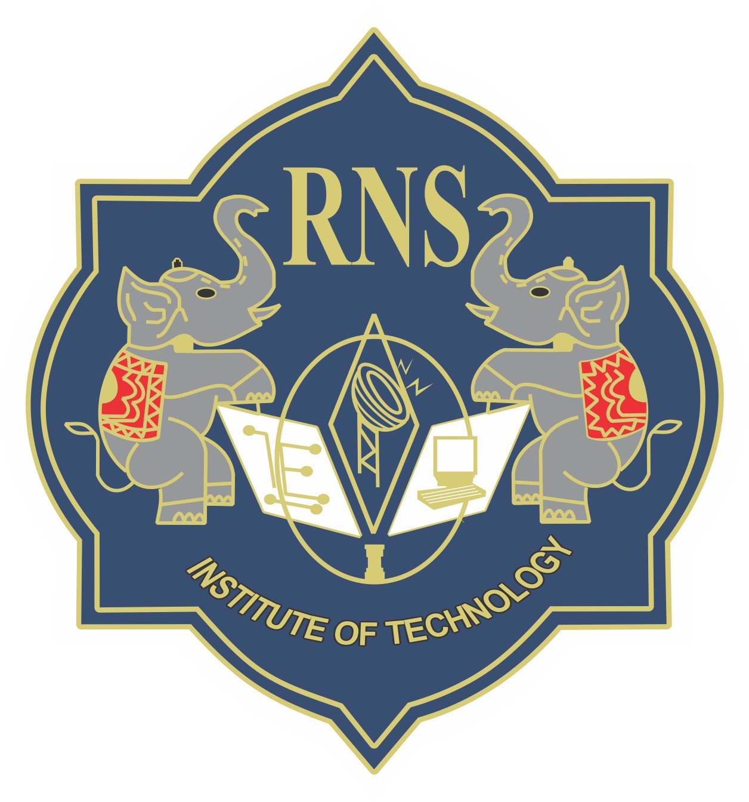

Department of Computer Science and Engineering
R N S Institute of Technology
Channasandra, Dr.Vishnuvardan Road, Bengaluru-560 098
2019-2020

R N S Institute of Technology
Channasandra, Dr.Vishnuvardan Road, Bengaluru-560 098

Department of Computer Science & Engineering

Internship CERTIFICATE

Certified that the Internship/ Professional Practice work entitled “Stock Market Trend Analysis” has been successfully carried out at “Pecten Labs Pvt. Ltd.“, by Ajay Deshpande bearing 1RN16CS005, bonafide student of RNS Institute of Technology in partial fulfillment of the requirements for the Final year degree in Bachelor of Engineering in Computer Science and Engineering of Visvesvaraya Technological University, Belagavi during academic year 2019-2020. It is certified that all corrections/suggestions indicated for Internal Assessment have been incorporated in the report deposited in the departmental library. The Internship report has been approved as it satisfies the academic requirements in respect of Internship work for the said degree.

Prof. Devaraju B M Dr. G T Raju Dr. M K Venkatesha
Assistant Professor Vice -Principal Principal
Dept. of CSE Professor, HoD-CSE

External Viva:
Name of the Examiners Signature with Date
1.
2.

Abstract
Predicting how the stock market will perform is one of the most difficult things to do. There are so many factors involved in the prediction – physical factors vs. psychological, rational and irrational behavior, etc. All these aspects combine to make share prices volatile and very difficult to predict with a high degree of accuracy.
Modern businesses run on data. However, if the source of the data is unstructured, extracting what you need can be labor-intensive. For example, you may want to pull information from the body of incoming emails, which have no pre-determined structure. Especially important for today’s enterprises is gleaning data from the web. Using traditional methods, web data extraction can involve creating custom processing and filtering algorithms for each site. Then one might need additional scripts or a separate tool to integrate the scraped data with the rest of your IT infrastructure.
Busy employees would prefer to spend time on doing the more meaningful tasks such as analysis. Any company that handles a high volume of data needs a comprehensive automation tool to bridge the gap between unstructured data and business applications.

i
ACKNOWLEDGMENT
At the very onset, I would like to place on record our gratefulness to all those people who have helped us in making this internship work a reality. Coming up with this Internship work to be a success was not easy. Our Institution has played a paramount role in guiding us in the right direction.
I would like to profoundly thank the Management of RNS Institute of Technology for providing such a healthy environment for the successful completion of this Internship / Professional Practice work.
I would like to express my sincere thanks to our respected Director, Dr. H N Shivashankar for his constant encouragement that motivated me for the successful completion of this work.

I would also like to thank our beloved Principal, Dr. M K Venkatesha, for providing the necessary facilities to carry out this work.

I am extremely grateful to our beloved Vice–Principal and HoD-CSE, Dr. G T Raju, for having accepted to patronize me in the right direction with all his wisdom.

I place my heartfelt thanks to all the Coordinators- Internship / Professional Practice. I would like to thank the internal guide Prof. Devaraju B M, Asst. Professor of Dept. of CSE, for his continuous guidance and constructive suggestions for this work.
It’s my pleasure to thank Pecten Labs Pvt. Ltd. for providing me the best platform to complete the internship work and glad to thank the extremal guide Mr. Ranga Vittal, for corporate exposure, training and guidance.
Last but not the least, I am thankful to all the staff members of Computer Science and Engineering Department for their encouragement and support throughout this work.

Ajay Deshpande
1RN16CS005

ii

